Overview
This is one of a series of Geometric Functions activities in which students explore functions geometrically. Because both the independent and dependent variables of a geometric function are points, students can vary the independent variable by dragging it and observe directly the behavior of the dependent variable. By tracing both variable points, the relationship between them becomes visible as an image on the screen. Students explore domain, range, composition, and inverse through direct manipulation of variables, and these concepts manifest themselves through visual images that reveal their fundamental aspects.
Many students may have met functions only in the numeric realm, and may not be aware as they begin these activities that function, transformation, and mapping are mathematical synonyms. This is an important mathematical connection for students: the Common Core State Standards for Mathematics states that students should “describe transformations as functions that take points in the plane as inputs and give other points as outputs.” [Standard G-CO2] This connection also provides an unparalleled learning opportunity, in that a student can easily create a function, drag the independent variable, and observe the behavior of the dependent variable. Because students use their sensory-motor systems to create and observe variation, this essential element of the function concept takes on a more vivid and deeper meaning. The distinction between the independent and dependent variables takes on concrete, physical meaning for students as they drag the input point and observe the effect on the output point. Domain and range take on a real, almost palpable existence as students restrict the independent variable to a path and observe the effect on the range. Function notation conveys a concrete significance, as an abbreviation to denote the particular transformation that the function performs upon its independent variable. And the composition of two geometric functions is easy for students to create and revealing to manipulate and explore.
Cognitive scientists use the term embodied metaphor to describe a physical object that represents a particular conceptual object (such as an independent variable, a domain, or a function), and stress the importance of concrete manipulations and observations in enabling students to form important mathematical concepts. By constructing a function, physically manipulating its independent variable, and observing the effect on the dependent variable, a student creates and interacts with an embodied function, helping her to build the critical abstractions that confer mathematical understanding and power: concepts of function, variation, dependency, and composition, useful notational systems, and so forth.
Functions exist in many mathematical realms; in fact, its usefulness in a variety of settings is at the heart of the power of the function concept. For this reason, it’s important that students make connections between functions in these different realms. For instance, they should connect geometric variation (as when they drag the independent variable of a Geometric Function) with numeric variation (as when they make a table of values for y = 2x – 3), and connect the range of a geometric function with the range of a numeric function.
Some of the Geometric Function activities specifically address these connections exploring multiple representations, or representations that are intermediate between the geometric and numeric realms. At the same time, all of the activities can be used to encourage discourse about how function concepts make connections across multiple representations and a variety of contexts. In fact, promoting discourse about these connections — encouraging vigorous and probing class discussions — is an important objective of these activities. For instance, students might discuss the relationship between restricting the domain of the geometric function R_{C,90°}(x) and restricting the domain of the symbolically-expressed numeric function f(x) = √ ̅x̅ .
The Geometric Functions activities include activities in which students:
- use prepared sketches to explore functions and function families,
- create, explore, and compare families of functions including reflection, rotation, dilation, and translation,
- express geometric functions using meaningful function notation,
- characterize function families based on the relative rate of change of the variables,
- drag a dependent variable to match the variation of the independent variable (function dance activities),
- create a function that produces a desired range from a given domain,
- create two functions and compose them,
- use composition to create and test inverse functions, and
- employ intermediate representations such as dynagraphs to relate geometric and numeric functions, and
- create static and animated graphics effects by applying a function to a photograph and animating either the function or the photo.

This Activity
In this activity, students create, explore, compare, and contrast three different families of geometric functions. By varying the independent variable and observing the functions’ behavior, students identify behavioral characteristics (such as relative rate of change and locations of fixed points) that are shared by members of a particular family, and that distinguish that family from other function families.
Students are expected to work purposefully in small groups. The instructions are at a fairly high level, so they must take care to plan carefully, to track their progress, and to use available resources and scaffolding as appropriate. Although the construction steps are not very difficult, students are more likely to be successful if they’ve completed at least one investigation that provides more detailed instructions.
This activity is suited to well-prepared students who have completed the Reflection Family activity without much difficulty and are prepared for a more challenging activity. Students who found the Reflection Family activity difficult may be better served by three separate activities (Rotation Family, Dilation Family, and Translation Family) that take a more explicit step-by-step approach.
In this activity, students will:
- Create two members each of three different function families (rotation, dilation, and translation).
- Investigate the behavior of each function by dragging the independent variable, observing the dependent variable, and noting patterns of covariation (by observing relative rates of change of the variables) and correspondence (using traces to observe patterns of corresponding variable locations).
- Identify the location(s) and patterns of fixed points (where the independent and dependent variables coincide) that characterize each family.
- Restrict the domain of an independent variable to a polygon, and observe the resulting range.
- Facilitate descriptions and discussions by using function notation to name the functions and their dependent variables.
- Identify the behavioral characteristics shared by the members of each family.
- Use differences in behavior to distinguish one family from another.
The concepts addressed in this activity include:
- Covariation: the relationship between the motions of the two variables
- Function notation: an efficient way to describe the action of the function
- Independent and dependent variables: the meaning of dependence
- Domain: a useful, agreed-upon restriction placed on the independent variable
- Range: the corresponding possible locations of the dependent variable
- Fixed points: locations where the input and output come together
Vocabulary: The activity assumes familiarity with the terms independent variable, dependent variable, function family, domain and range.

Introduce
1. Open the presentation sketch Compare Function Families Present.gsp.
Project the sketch for viewing by the class. Expect to spend about [xx] minutes.
2. Go to the Skills page and have a student demonstrate for the class the first few steps of the construction. It’s important to have a student operate the program for this demonstration. It’s also important not to spend too much time and not to go through the entire construction; leave students room to explore the behavior of the function. (If students have already done the Reflection Family activity, demonstrate only the first step: creating an angle parameter labeled θ.)
3. If needed, remind students about using the Help menu, and particularly the Sketchpad Tips (Help | Using Sketchpad | Sketchpad Tips) and the Reference Manual (Help | Reference Manual). (Don’t encourage use of the video tips unless you have headphones attached to your computers.) You can also pass out several copies of the Construction Tips page from which students can get more detail about specific techniques.
4. Explain, In this activity you will explore several families of functions: rotation, dilation, and translation. For each family you will try to figure out how the members of that family are similar to each other, and how they are different.
5. Have a student demonstrator go to the Sample Responses page. Explain, As you work, you can record your observations, and your answers to the questions, right on the sketch, just like this student did. That will make it easy for you to present your work, and for others to see how you reached your conclusions. Notice that the student used Hide/Show buttons and Animation buttons to help show her work.
6. Say, Let’s see how this student answered the first question after she constructed the reflection. Tell the student demonstrator to drag x up and down. Ask, For question 1, let’s see what happens when x is dragged down. Which way does the dependent variable move? Elicit student observations. Then say, Now drag x sideways along the bottom of the domain. Which way does the dependent variable move now? Connect the responses that you elicit to the step 1 observations recorded in the sketch.
7. Tell the student demonstrator go to the Characteristics page. Explain, Finally, let’s look at how this student summarized the Reflection Family on her paper. What did she write for the Family Name? [Elicit student responses.] What abbreviation did she write for the function, and what does her abbreviation mean? Pointing to the r_{j}, elicit student responses, which should include “reflect across mirror j.” What did she name her independent variable? {Responses] How did she abbreviate her dependent variable? Elicit student responses, settling on “r_{j}(x) means the reflection across j of x.” Check for understanding of this notation. If appropriate, return to the Sample Responses page to concretely illustrate the meaning.
8. Continuing on the characteristics page, explain, Now let’s look at how she described the function’s behavior. How did she describe what the function does? [It reflects across mirror j.] What did she say about the relative speed of the variables? Does this match what we just saw? [The speeds are the same, as we saw.] What about the relative direction of the variables? [The direction depends on whether x is moving parallel to the mirror, perpendicular, or in some other direction.] And what fixed points did she find? [When you reflect points that are already on the mirror, they stay right where they are.]
9. Explain, You’re going to work in pairs to investigate other important function families: rotation, dilation, and translation. For each family, be sure to write your answer for each question, to fill in a Characteristics Table, and to have an animated sketch that you can use to present your conclusions.

Develop
10. Assign student pairs to computers and distribute the worksheet and the blank Function Family Characteristics tables. (If you want students to record answers to the questions on paper rather than in their sketch, you may want to pass out three copies of the provided Answer Sheet to each pair.) Tell pairs to agree on their answers to each question as they record it on their sketch, or on separate paper as you determine. Tell pairs to switch control of the mouse and keyboard each time they reach step 6. (The first partner controls steps 1–5 for the first function, the second controls step 6 for the first function and steps 1–5 for the second function, and so on.)
Expect students at computers to spend about [xx] minutes.
11. Circulate as students work. Students may need prompting questions to help them move the independent variable in ways that reveal behavior, and to help them make insightful observations. Note questions and difficulties that arise, and encourage students to raise particular difficulties they had or things they noticed during the concluding whole-class discussion.
12. Collect, on a flash drive, student sketches to use during the discussion. Make a point of collecting sketches where students had issues or misconceptions that are worthy of general discussion, as well as sketches that are good illustrations of particular topics to address during the summary discussion. As you collect sketches, consider the order in which you want to show them, in order to correct misconceptions and to review the process through which students came to understand the relationship between the relative rate of change of the variables and the relative shape and orientation of the domain and range.
13. Students who finish early should be encouraged to explore the Glide Reflection family.

Summarize
12. Gather the class. Students should have their worksheets with them. Give students the opportunity to discuss difficulties or misconceptions that they experienced.
Project the sketch. Expect to spend about [xx] minutes.
13. Display particular sketches that you collected to illustrate important elements for the discussion, being sure to validate students’ efforts to observe, and to emphasize the value to the entire class of making mistakes, contemplating them, and persevering in order to learn from them.
14. Ask students to discuss the comparison chart, and ask them to explain how their observations about covariation (the way in which variation of the independent and dependent variables relate to each other) serve to distinguish one function family from another. Try to make sure that all students understand and can apply this idea.
15. In preparation for the Function Challenge activity, ask students to explain the connection of fixed points to the parameters of the function (for example, that the fixed points of a reflection would allow you to find the mirror if you didn’t know where it was).

Assess
16. As students leave, ask them to fill out an exit slip describing one important thing they learned, and one thing that they’re not sure about.

Answers
1. The speed and direction of the variables for each function are summarized in the Function Family Characteristics table.
2. Drawings will vary, but should be roughly consistent with the domain.
3. For reflection, rotation, and translation the range is congruent to the domain, but flipped, rotated, or translated. For dilation, the range is similar to the domain, smaller or larger according to the scale factor.
4. When speeds are the same, the range is congruent to the domain; when speeds are different, the range is similar to the domain, either larger or smaller. When directions are different, the domain is turned or flipped relative to the domain.
5. For the same domain, the range for two different functions of the same family has the same fundamental characteristics; only the details change. These details include the direction and distance of the flip for rotation, the center and the turn angle for rotation, the center and the scale factor for dilation, and the distance and direction of the slide for translation.
6. Dragging the center point affects the location of the range, but not the amount by which it’s turned or scaled. Changing the vector for translation changes the location of the range, but not its size, shape, or orientation.
7. Here are possible sample entries in the Function Family Characteristics table:
Family: | Reflection
Notation: | Function | Independent variable | Dependent variable
Notation: | r_{j} | x | r_{j}(x)
Description: | Reflect across mirror j
Relative Speed: | The variables move at the same speed.
Relative Direction: | When x moves parallel to the mirror, r_{j}(x) moves in the same direction. When x moves perpendicular to the mirror, r_{j}(x) moves in the opposite direction.
Fixed Points: | The fixed points are the points on the mirror.
Family: | Rotation
Notation: | Function | Independent variable | Dependent variable
Notation: | R_{C,90°} | y | R_{C,90°}(y)
Description: | Rotate about center point C by 90°.
Relative Speed: | The variables move at the same speed.
Relative Direction: | When y moves up, R_{C,90°}(y) moves left; when y moves left, R_{C,90°}(y) moves down. R_{C,90°}(y) always moves 90° clockwise from the movement of y.
Fixed Points: | The only fixed point is the center point C.
Family: | Dilation
Notation: | Function | Independent variable | Dependent variable
Notation: | D_{C,0.5} | p | D_{C,0.5}(p)
Description: | Dilate about center point C by 0.5.
Relative Speed: | The dependent variable moves at half the speed of the independent variable.
Relative Direction: | The two variables always move in the same direction.
Fixed Points: | The only fixed point is the center point C.
Family: | Translation
Notation: | Function | Independent variable | Dependent variable
Notation: | T_{AB} | w | T_{AB}(w)
Description: | Translate by the vector from A to B.
Relative Speed: | The variables move at the same speed.
Relative Direction: | The variables move in the same direction.
Fixed Points: | There are no fixed points.
Family: | Glide Reflection (from the Explore More)
Notation: | Function | Independent variable | Dependent variable
Notation: | G_{AB} | z | G_{AB}(z)
Description: | Glide reflect using the segment from A to B.
Relative Speed: | The dependent variable moves at the same speed.
Relative Direction: | When the independent variable moves in the direction of the vector, so does the dependent variable. But when the independent variable moves perpendicular to the direction of the vector, the dependent variable moves in the opposite direction.
Fixed Points: | There are no fixed points.

In this activity you will compare the rotation, dilation, and translation families. For each family you will transform a point (the independent variable) and describe the behavior of the transformed point (the dependent variable). Then you will compare the different families with each other.
Begin with a new sketch, and construct and observe each family on a different page of the sketch. For each family, follow these steps:
1. On a new page of the sketch, prepare a parameter or vector.
(a) For rotation, create an angle parameter θ and mark it as the angle.
(b) For dilation, create a parameter scale and mark it as the scale factor.
(c) For translation, construct a segment AB and mark it as the vector.
To name the parameter θ, type its label as {theta}, using curly brackets.
2. Construct point x and transform it. Label the dependent variable: for example, R_{C,θ}(x), or D_{C,scale}(x), or T_{AB}(x).
3. Vary x by dragging it up and down, and then left and right. Observe the behavior of the dependent variable.
Be sure to select only point x.
Q1 As you drag x, what is the direction and relative speed of the dependent variable? What else do you notice about the motion of the two variables? Can you find any fixed points? If so, where are they?
To restrict the domain, select the polygon and x. Choose Edit | Merge Point to Polygon.
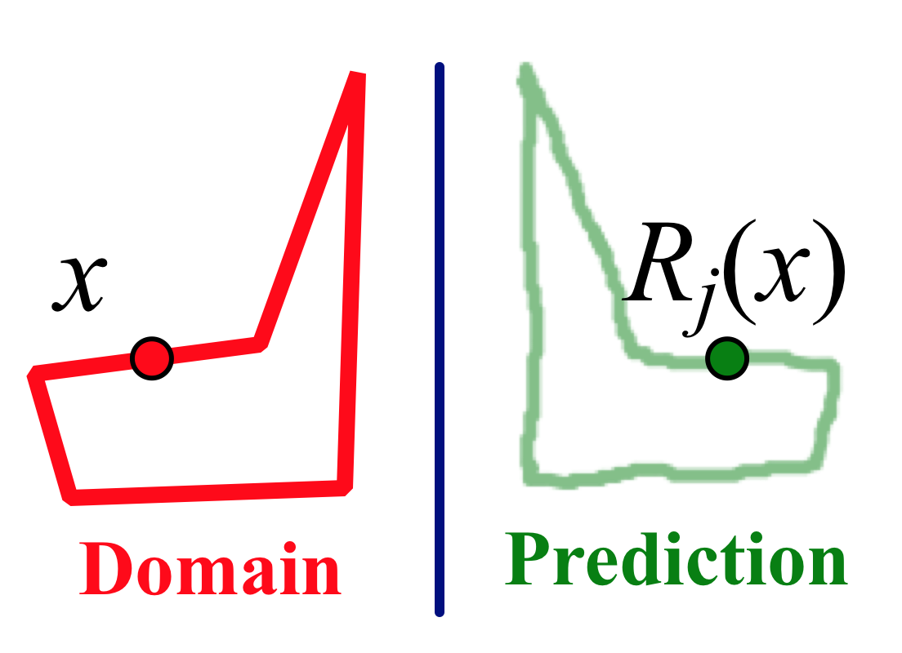
4. Construct a polygon and restrict independent variable x to the polygon’s border (the domain). Turn on tracing for the dependent variable.
Q2 Draw with the Marker tool to predict the path of the dependent variable.
5. Drag the independent variable along its domain, so that the dependent variable traces out the range.
Q3 How are the range and domain similar, and how are they different? Consider position, size, angle, and anything else you think of.
Q4 How do the two shapes relate to your observations from Q1 about the relative speed and direction of the variables when you dragged x?
6. Construct a different member of the family, using a different angle, scale factor, or vector. Restrict its range to the same polygon, and trace the dependent variable as you vary the independent variable.
Don’t move the center point (if this family uses one).
Q5 How does the range of the new function compare to the range of the first? What is similar, and what is different, about these two functions?
Q6 Change the function again by dragging the center point or vector. How does this change affect the range?
Drag the entire vector, not just an endpoint (if this family uses a vector).
Q7 Fill in the table of Function Family Characteristics for this family.

Explore More
Explore the Glide Reflection family, and create a presentation sketch and a Family Characteristics table for this function. The Glide Reflection function is not built into Sketchpad, but you can create it by combining two other functions: a translation and a reflection, both using the same segment (as the vector and the mirror).
7. In a new sketch, construct segment AB.
8. Mark points A and B as a vector for translation, and mark segment AB as a mirror.
9. Construct an independent variable x. Translate it, and then reflect the translated image.
10. Hide the translated image, so you have only the independent variable and the final image point. Label the dependent point G_{AB}(x).
11. Drag point x and observe the behavior of its glide reflection. Investigate the relative speed and direction of the variables.
12. Construct a polygon and restrict the domain of x to the polygon. Trace the dependent variable to show the range, and compare domain and range.
14. Select x and G_{AB}(x) and choose Transform | Define Custom Transform. Name the custom tranformation Glide[AB]. This adds your glide reflection to the bottom of the Transform menu.
15. Select the transformed point G_{AB}(x) and choose Transform | Glide[AB]. What happens?
16. With the transformed point still selected, choose Transform | Glide[AB] several more times.
16. Drag point x to observe the effect. Then turn on tracing for all the transformed points and drag again.

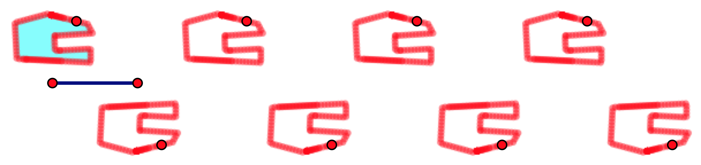

Construction Tips
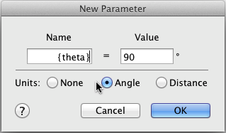
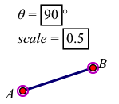
1. To create angle parameter θ, choose Number | Parameter, click the Angle radio button to make it an angle parameter, and type its label using curly brackets like this: {theta}. To mark it as the angle, select the parameter and choose Transform | Mark Angle. To create and mark parameter scale, choose Number | Parameter, type its label, and set its value. Then choose Transform | Mark Scale Factor. To create and mark vector AB, use the Segment tool to make a segment and use the Text tool to label its endpoints. Then select points A and B in order and choose Transform | Mark Vector.

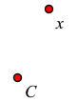
2. To construct x, use the Point tool, and then use the Text tool to label it. For rotation and dilation you will also need a center point C. To mark C as the center of rotation, select it and choose Transform | Mark Center. (If you forget to mark the center or the parameter ahead of time, you can click them in the sketch once the Rotation or Dilation dialog box is open.)

3. If you switched to the Text tool or the Segment tool, be sure to choose the Arrow tool before dragging.
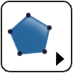
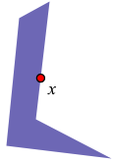
4. To construct a polygon, use the Polygon tool. Finish the polygon by clicking again on the first vertex, or by double-clicking as you construct the last vertex. After constructing the polygon, you may want to hide its vertices: select them with the Arrow tool and choose Display | Hide Points. To restrict the independent variable to the polygon, select both objects (the independent variable and the polygon) and choose Edit | Merge Point to Polygon. To turn on tracing the the dependent variable, select it and choose Display | Trace Point.
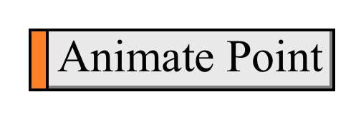
5. Instead of dragging, you can select the independent variable and choose Display | Animate Point. Or you can make an animation button by selecting x and choosing Edit | Action Buttons | Animation.
6. To construct a different member of the family, repeat the earlier directions for steps 1 through 3, using new parameters, a new center point, and a new independent variable. To avoid confusion, name these objects differently from the originals. When you reach step 4, merge your second independent variable to the same polygon you created earlier. This will make comparisons easier.

Answer sheet for the _______________________________ function family
Q1 As you drag x upward, what is the direction and relative speed of the dependent variable? What else do you notice about the motion of the two variables? Can you find any fixed points? If so, where are they?

Q2 Draw with the Marker tool to predict the path of the dependent variable. [Sketch the domain and range below.]

Q3 How are the range and domain similar, and how are they different? Consider position, size, angle, and anything else you think of.

Q4 How do the two shapes relate to your observations from Q1 about the relative speed and direction of the variables when you dragged x?

Q5 How does the range of the second function compare to the range of the first? What is similar, and what is different, about these two functions? [Sketch the domain and range below.]

Q6 Change the function again by dragging the center point or vector. How does this change affect the range?
Function Family Characteristics
Family Name: | Reflection
Notation: | Function | Independent variable | Dependent variable
Notation: | r_{j} | x | r_{j}(x)
Description: | Reflect across mirror j
Relative Speed: | The variables move at the same speed.
Relative Direction: | When x moves parallel to the mirror, r_{j}(x) moves in the same direction. When x moves perpendicular to the mirror, r_{j}(x) moves in the opposite direction.
Fixed Points: | The fixed points are the points on the mirror.
Family Name:
Notation: | Function | Independent variable | Dependent variable
Description:
Relative Speed:
Relative Direction:
Fixed Points:
Function Family Characteristics
Family Name:
Notation: | Function | Independent variable | Dependent variable
Description:
Relative Speed:
Relative Direction:
Fixed Points:
Family Name:
Notation: | Function | Independent variable | Dependent variable
Description:
Relative Speed:
Relative Direction:
Fixed Points:

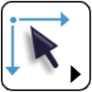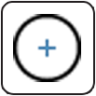
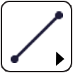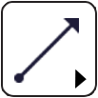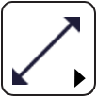
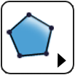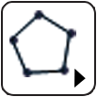





Geometric Functions (plural, capitalized) is used here to refer to this sequence of activities in which students explore geometric transformations as functions. A geometric function (in lowercase) is used here to refer to any transformation that takes a point to a point.
We use the term physical here (and avoid distinguishing between physical and virtual), to stress students’ concrete physical experiences interacting with these objects. They use their physical motor system to create them, drag them, and attach them to other objects, and their interactions are guided by their visual observations of the effect of their actions. The same hand-eye coordination that’s important in sports performance also plays a role here.

